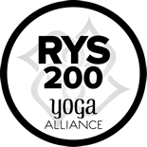
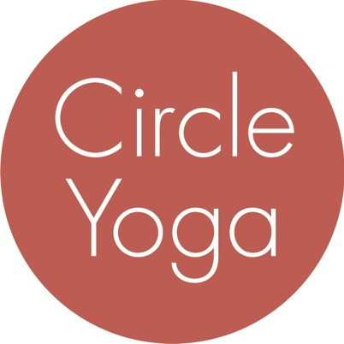
Circle Yoga
200-hr Teacher Training
Application

First Name: ___________________________ Last Name: ___________________________
Street Address: ______________________________________________________________
City/State/Zip: _______________________________________________________________
Primary Phone: ________________________ Alternate Phone: _______________________
Email: _____________________________________________________________________

Do you currently attend classes at Circle Yoga? _______

Are you applying for this training as part of the Children’s Yoga Teacher Training Collaborative
(www.childrensyogattc.com)? ________

Please tell us about your practice, your background, and your interest in the program by answering the questions below. Limit each answer to 200 words or less.

- Tell us about your experience with yoga so far. (For example: How long have you been practicing? What style(s) of yoga do you practice? Where do you practice and/or who are your primary teachers? Describe your typical practice.)

- Do you have any experience with meditation or mindfulness practices? If so, please describe.

- Why do you want to take a 200-hr teacher training?

- What draws you to the 200-hr teacher training at Circle Yoga in particular?

- How do you plan to apply your yoga skills in your work and/or personal life after you complete this training?

- If you are planning to teach yoga, what other skills, qualities, or experiences do you have that will add to your teaching?

Send your completed application to cytt@circleyoga.com. Your application will be considered after we have received your non-refundable application fee of $50 through our online registration system. At that point, if we are not already familiar with your practice, we will ask you to come to the studio for a trial class with one of our CYTT trainers within 21 days.

