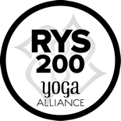
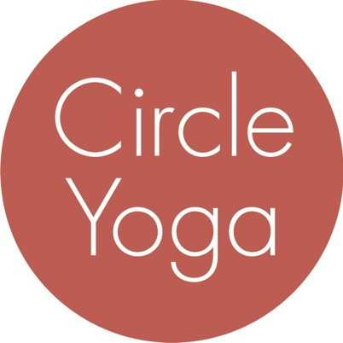
Circle Yoga
200-hr Teacher Training
Application

Date:
Name:
Street Address:
City/State/Zip:
Primary Phone:
Alternate Phone:
Email:

Do you currently attend classes at Circle Yoga?

Are you applying for this training as part of the Children’s Yoga Teacher Training Collaborative
(www.childrensyogattc.com)?

Please tell us about your practice, your background, and your interest in the program by answering the questions below. Limit each answer to 200 words or less.

- Tell us about your experience with yoga so far. (For example: How long have you been practicing? What style(s) of yoga do you practice? Where do you practice and/or who are your primary teachers? Describe your typical practice.)

- Do you have any experience with meditation or mindfulness practices? If so, please describe.

- Why do you want to take a 200-hr teacher training?

- What draws you to the 200-hr teacher training at Circle Yoga in particular?

- How do you plan to apply your yoga skills in your work and/or personal life after you complete this training?

- If you are planning to teach yoga, what other skills, qualities, or experiences do you have that will add to your teaching?

Send your completed application to cytt@circleyoga.com. Your application will be considered after we have received your non-refundable application fee of $50 through our online registration system. At that point, if we are not already familiar with your practice, we will ask you to come to the studio for a trial class with one of our CYTT trainers within 21 days.

