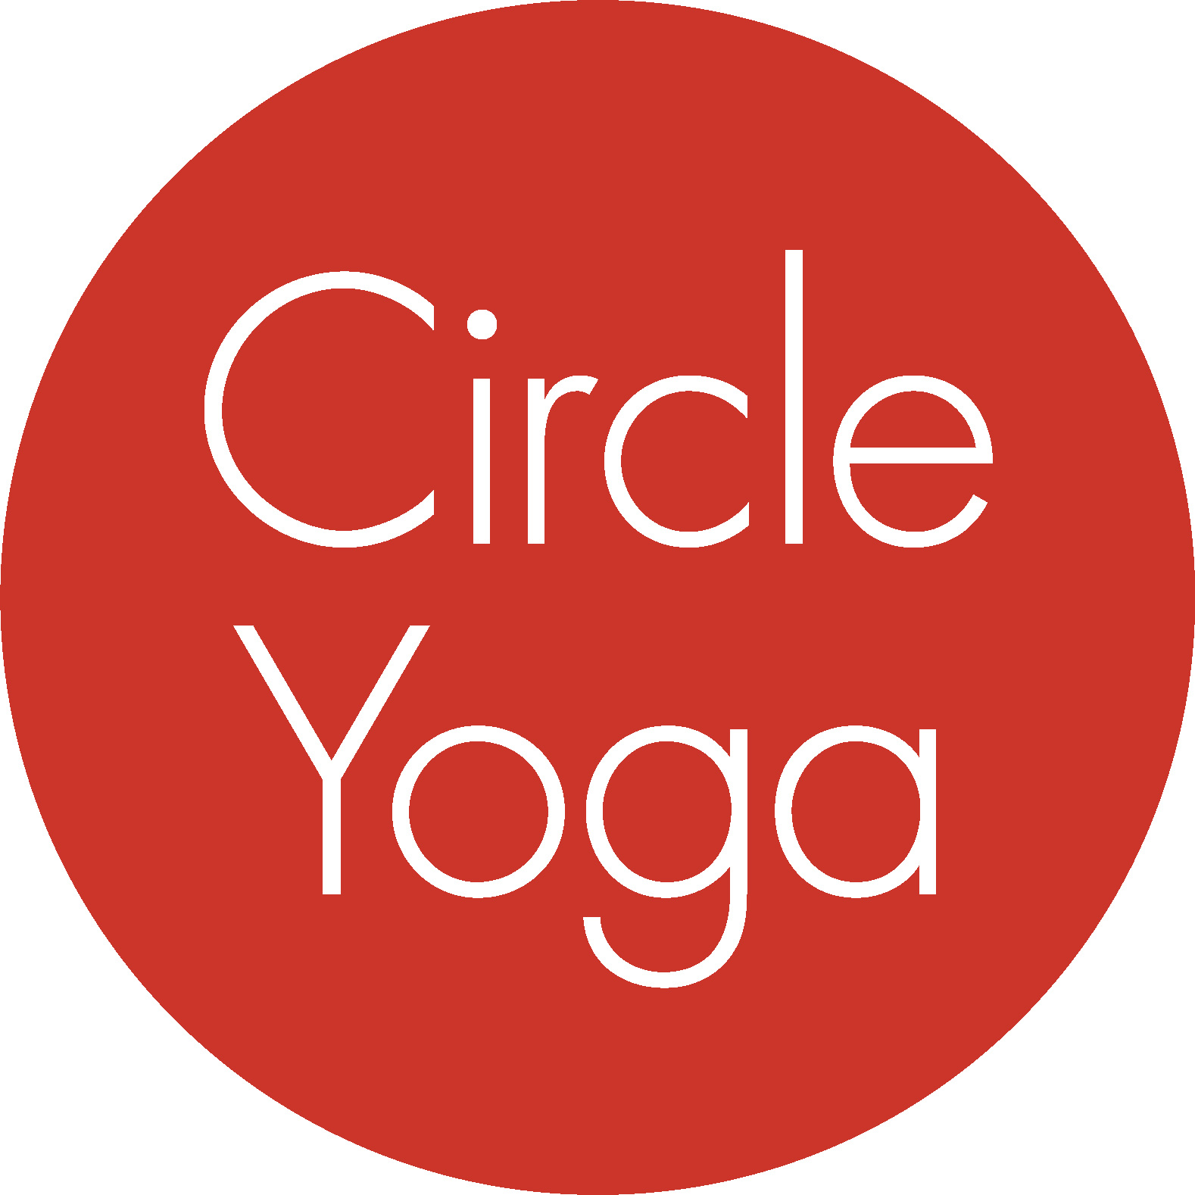
300-hour Circle Yoga
Teacher Training
Application

Date:
Name:
Street Address:
City/State/Zip:
Primary Phone:
Alternate Phone:
Email:

Please tell us about your practice, your background, and your interest in the program by answering the questions below. Limit each answer to 300 words or less.

- Please tell us about your yoga practice—asana, meditation, breathing, and philosophy.

- Please tell us how you would describe the effects of yoga in your life.

- Where and when did you complete your 200-hour teacher training? Why do you want to take a 300-hour?

- What draws you to the 300-hour teacher training at Circle Yoga in particular?

- Have you been teaching yoga, and if so, how would you describe your teaching?

5. Please provide a brief professional reference: have a student, colleague, or teacher email cytt@circleyoga.com.

Send your completed application to cytt@circleyoga.com. Your application will be considered after we have received your non-refundable application fee of $50 through our online registration system. At that point, if we are not already familiar with your practice, we may ask you to come to the studio for a trial class with one of our CYTT trainers.

